PRACTICAL 1

Aim: Create new flutter project using each of the following:
1. Terminal
2. VS Code
3. Android Studio
• Run the above created flutter project in Android emulator using:
1. Terminal
2. VS Code
3. Android Studio

Steps:
Creating a New Flutter Project

Using Terminal
- Open the terminal.
- Navigate to the directory where you want to create your project.
- Run the following command to create a new Flutter project: flutter create
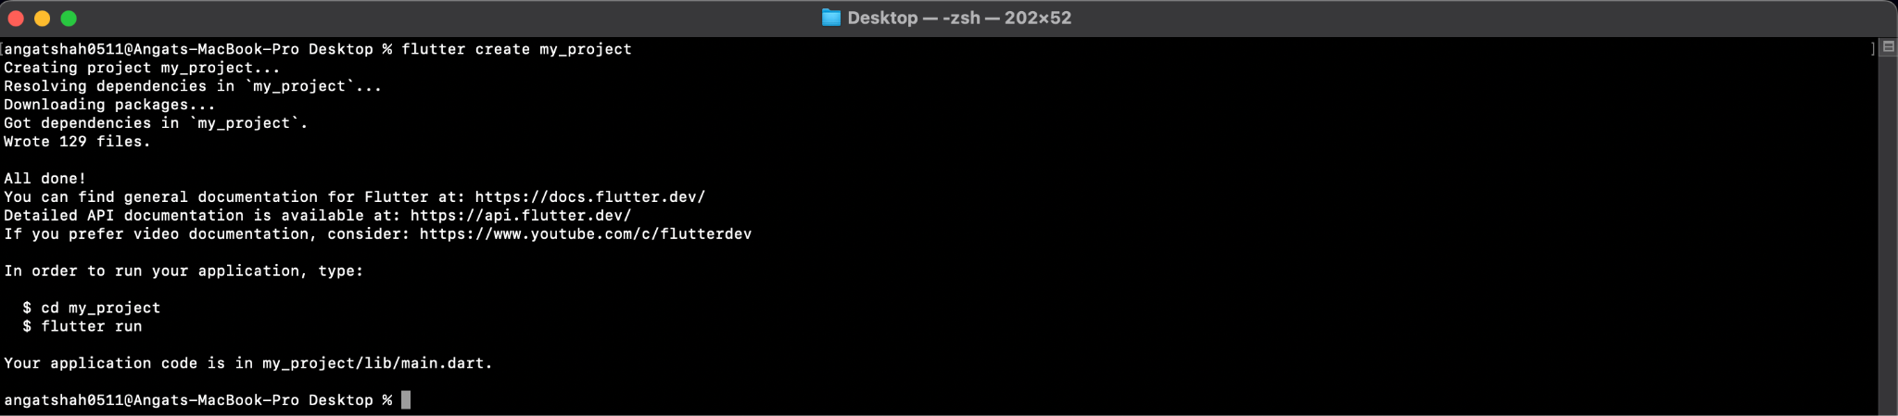
Using VS Code
- Open the Command Palette with ‘cmd + Shift + P’.
- Type ‘Flutter : New Project’ and select it. Follow the prompts to specify the project name and location.
- VS Code will automatically open the new Project Directory.
Using Android Studio
- Open Android Studio
- Click on ‘Start a new Flutter Project’ on the Welcome Screen. Choose ‘Flutter Application’ and click ‘Next’.
- Configure the Project. Fill in the required fields (Project name, Project location, etc.). Click ‘Finish’ to create and open the project.

Run the Flutter Project in Android Emulator
Using Terminal
- Open the terminal.
- Start the iOS Emulator
- Run the project using the following command: flutter run
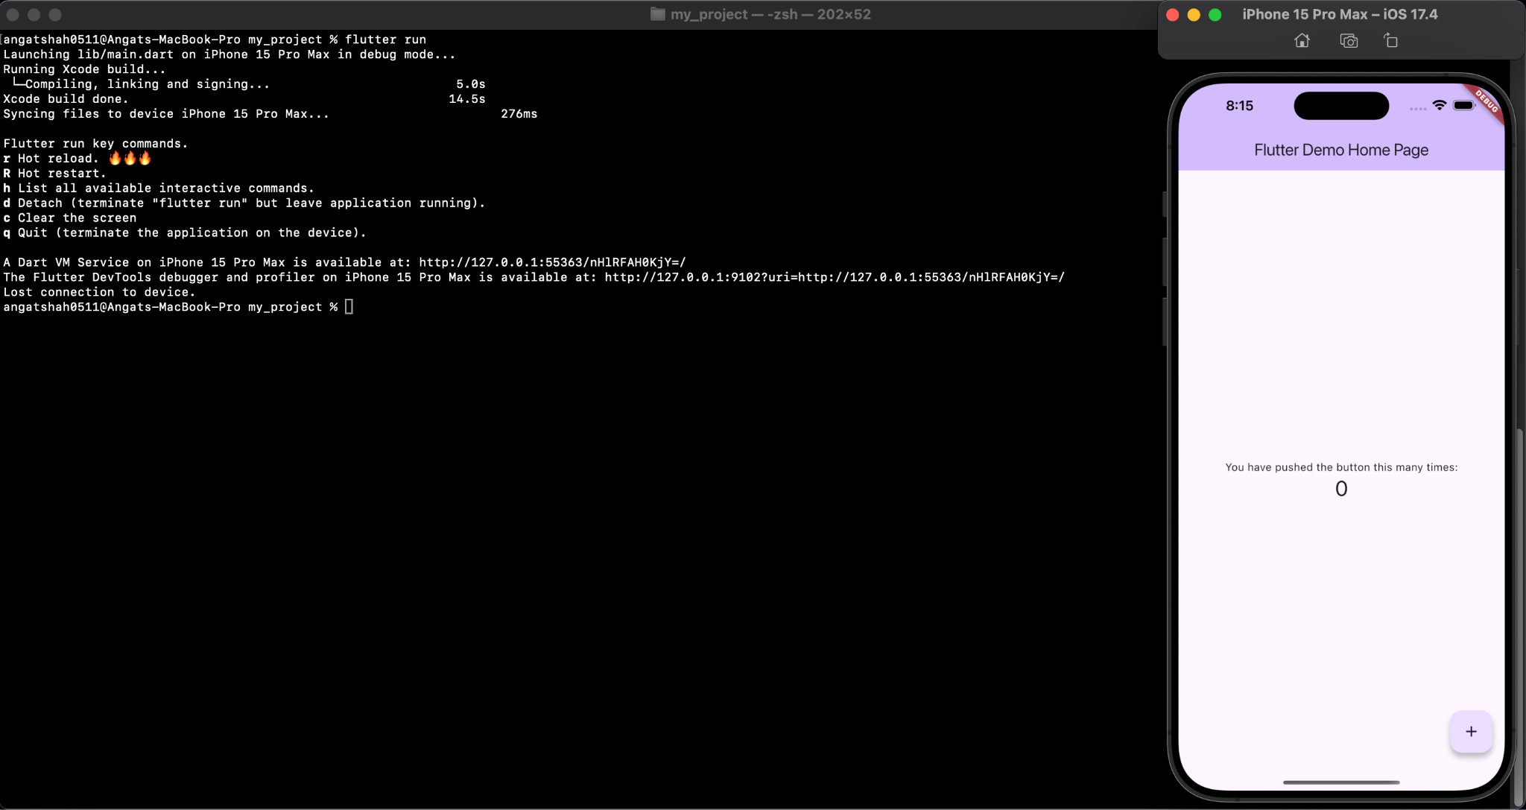
Using VS Code
- Open the Debug Panel by clicking on the Run and Debug icon on the sidebar or press ‘cmd + Shift + D’.
- Select Device
- Run the Project by clicking ‘F5’ to start debugging, which will build and run your Flutter app on the selected emulator.
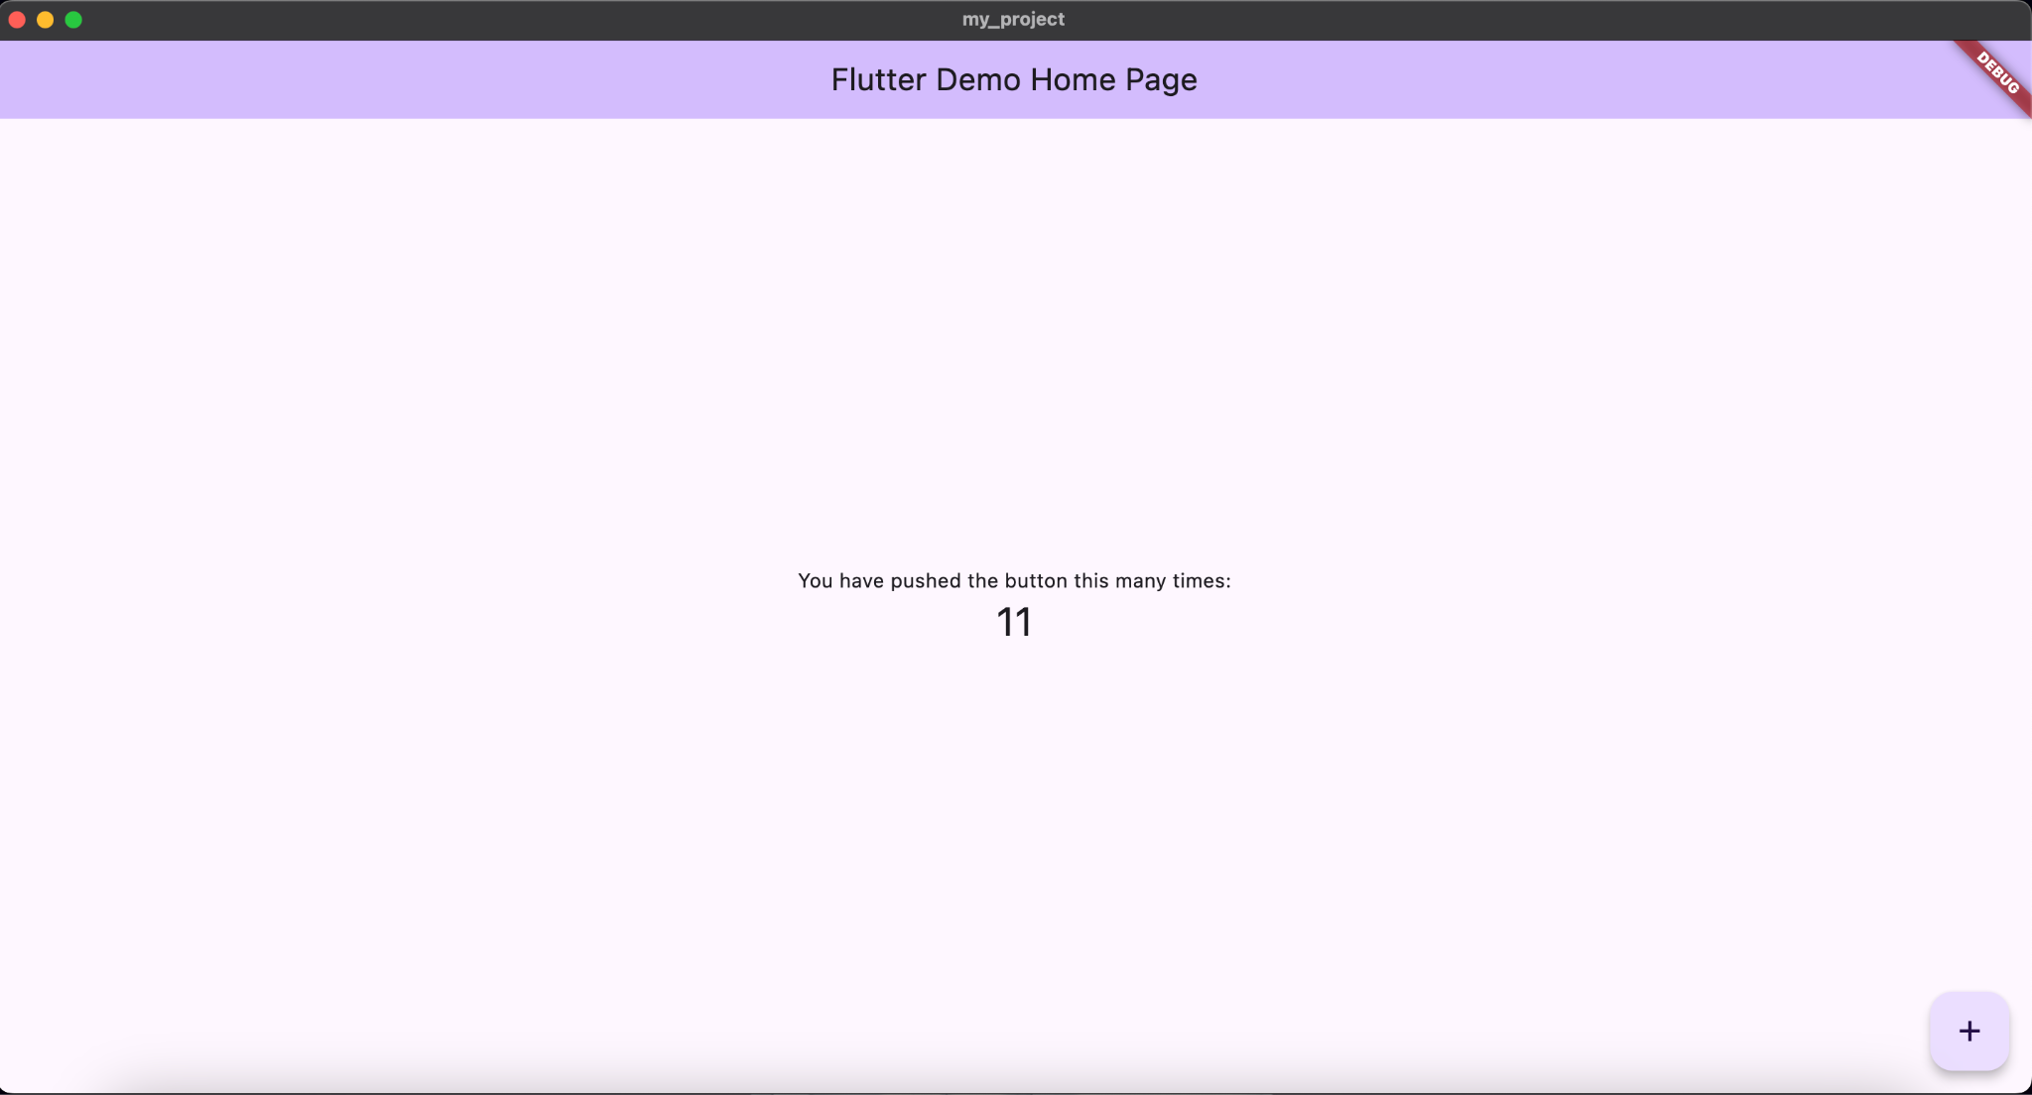
Using Android Studio
- Open Android Studio
- Start the Android Emulator. You can start the emulator by going to ‘Tools’ > ‘AVD Manager’, and then clicking on the play button next to your emulator.
- Run the Flutter Project : Click on the green run button (play icon) in the top-right corner of the IDE.
